In some instances, we wish to observe the dissemination of particular definite objects in a treatment. To determine whether the theorized distribution is valid, we use the chi-square goodness test.
Chi-square test for homogeneity is applied to test if the dissemination of a particular object distribution is different for binary or more population. We will arrange our facts into a mutual arrangement.
It’s probable to apply the facts in the mutual arrangements to determine the association between definite binary objects. To define whether there is a degree of connotation amid the variable in treatments at broad, we use the chi-square test for independence.
Mars Incorporated is used to make milk chocolate sweeties; M&Ms. The user affairs section gave us the following facts about the dissemination of paint in M&Ms chocolate Candies made from milk. On typical, the fresh mixture of color will be as follows, thirteen out of a hundred red, thirteen out of a hundred brown, fourteen out of a hundred yellow, sixteen out of a hundred green, twenty out of a hundred orange and twenty-four out of a hundred blue.
We purchase a bag of M&Ms to test their claim. We find the following number of information:
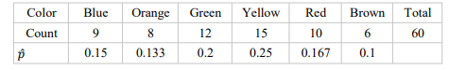
Due to the organization believe that twenty-four percent of total M&Ms are blue, we suspect there are fishy deals accepted on.
Here we can use single sample Z-test to experiment the hypothesis for the proportion:
Ho: q= 0.24 and
H1: q≠ 0.24
Where q represents the original population percentage of M&Ms of blue color.
We can also determine the significance tests for the remaining colors of each. Determining Z-test for each remaining color proportion will not be efficient and will create multi-comparison problems.
Examining a single object Z-tests for to each remaining pigment will direct you on the way to get a random Acting single-sample Z assessments for to each pigment wouldn't explain to you how possible you can compute random illustration of sixty chocolates that is different from the one that the company proposed as this one claims.
For that reason, we need to apply a new type of significant experiment known as Chi-square golly of appropriate analysis.
The Ho assumption of chi-square golly of appropriate assessment must always list and explain about the dissemination of a particular definite object in the populace of importance.
This substitute assumption of chi-square golly of appropriate examination, thee definite object lacks a specific distribution.
The assumption can also be written in symbol;
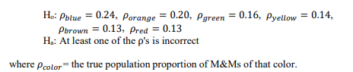
The idea of applying the Chi-square golly experiment is to compare experiential counts from our tester with counts from those expected from Ho, whether accurate.
When we experience more experiential counts than from anticipated counts, the extra facts we have contrary to Ho.
Assuming provided information given by Mars company is factual that twenty-four percent of total produced candies are blue. For a typical tester of sixty sweeties, the total sum of azure sweets would be 24/100*60=14.4. Mars Inc. remains true. 24% of all M&Ms manufactured are azure. In an unplanned sample of sixty chocolates, the ordinary amount of azure M&Ms must be (24/100) *60= 14.4. using the same process, we can determine the estimated counts for each of the reaming colors
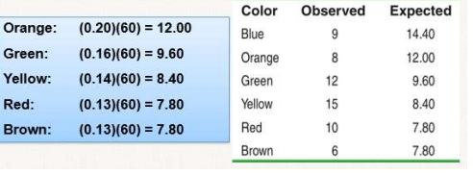
To test whether the given evidence against the null assumption, we try to relate the estimated tallies since our tester from that of expected reckoning presumptuous that Ho is factual. This is if the estimated counts are much greater then expected tally, this is the fact we are interested in.
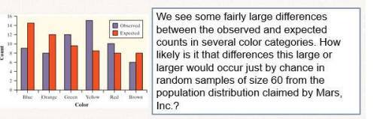
To find the solution to this problem, we compute an indicator that determines the variation amid the experiential tally and anticipated tally. We apply a chi-square test to resolve this.
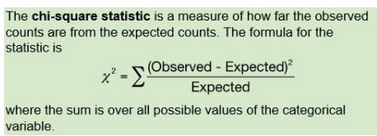
The table bellows show the total counts for both expected and observed counts of our tester of sixty M&Ms. Let's calculate the chi-squared statistic.
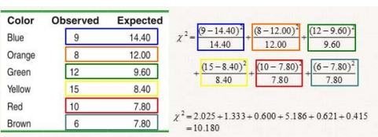
C 2 estimate the distance between the observed tally and expected tally. Prominent figures of χ 2 are stouter proof against Ho because observed scores are much further from expected tally if Ho was correct. Secondary data of χ 2 propose that the facts are reliable with the Ho.
The specimen dissemination of a chi-square indicator cannot be Ordinary dissemination, but rather a Right-skewed dispersal, which permits merely the following figure for a reason being 2 will certainly not be negative.
Anticipated tallies are expected to be five at minimum. This specimen of dissemination of χ 2 measurements will be adjacent to chi-square dissemination, having a gradation of independence that is equivalent to the sum of groups less 1.

We will compute a chi-square measurement for our tester of sixty M&Ms, χ 2 = 10.18. Since the sum of total probable tallies is five, at least, the χ 2 measurement will come second after chi-square dissemination. It has a degree of freedom= 6 - 1 = 5 practically when Ho is accurate.
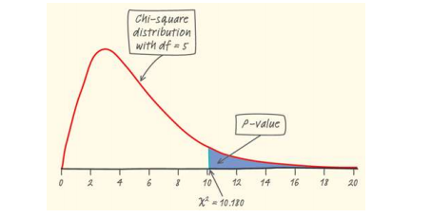
Using our calculator, we discover the P-figure to be 0.0703. Thus, we can’t afford to reject Ho if α = 0.05. we lack enough facts to conclude that what the company claimed is correct.

